Start splash screen 1 – Logo (Image) | 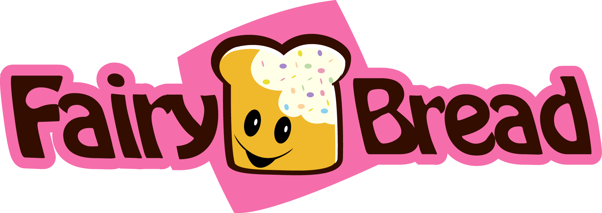
Start splash screen 2 – Welcome to Country (Text and Image) | Welcome to Country  We acknowledge the Traditional Owners of the country on which we are meeting. We pay our respects to their Elders, past and present, and the Elders from other communities who may be here today.  
Start splash screen 3 – Proudly Geelong Image | 
Application Screen  Button icon– Exit (Close App)  Button icon– More Info (Open website http://www.fairybreadgames.com)  Button icon – Play Now (Starts Game) | 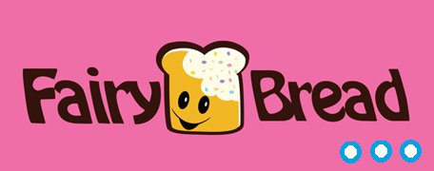  Buttons to use app
Page 1 – Play Now | Buttons  - Play button  - Pause button  - Next button  - Stop / exit button at the  Play button pressed  - Random word comes up and timer in back ground of screen counting down (+- 100 RANDOM WORD LIST)  - Next word button - User has option to go to the next word  - Timer starts to count down from 45 seconds to zero seconds  - Timer stops and go back to Play Now screen (Page 1)  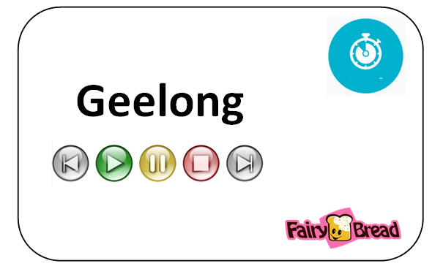
Close Application Button | Close application

